**Web Programming B**

**Salman Umar**

**I220908**

**Task 01**

<https://github.com/SalmannUmarr/ArtGallery>

**Manual Website**

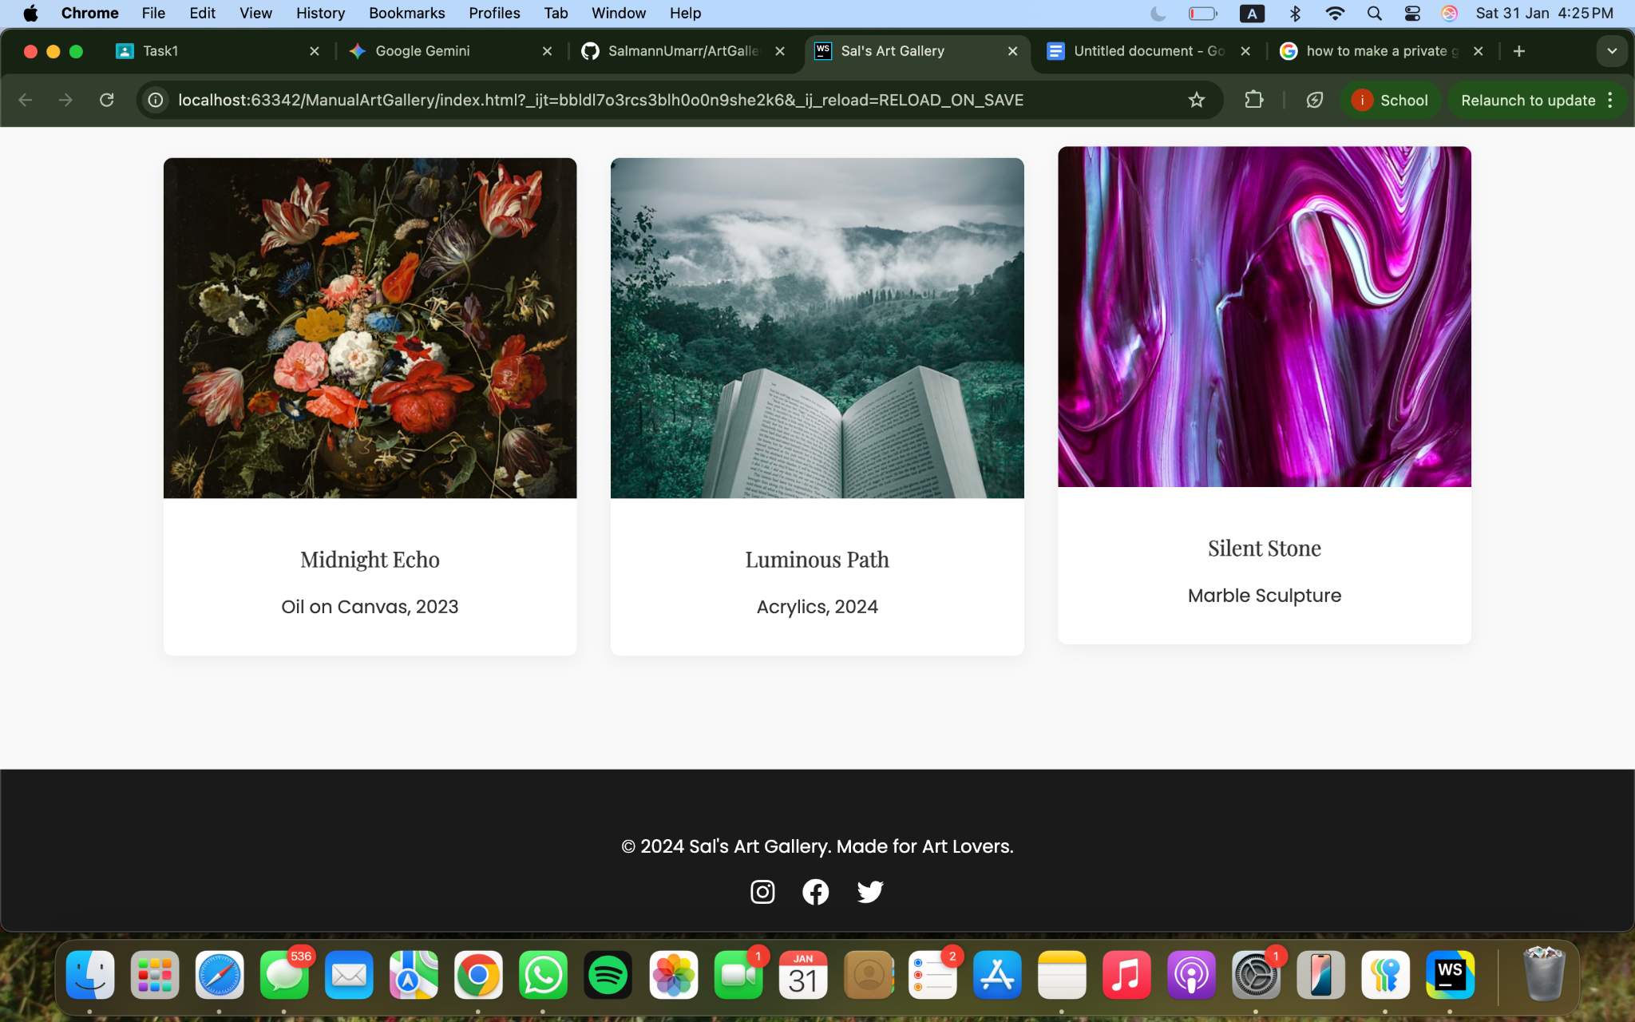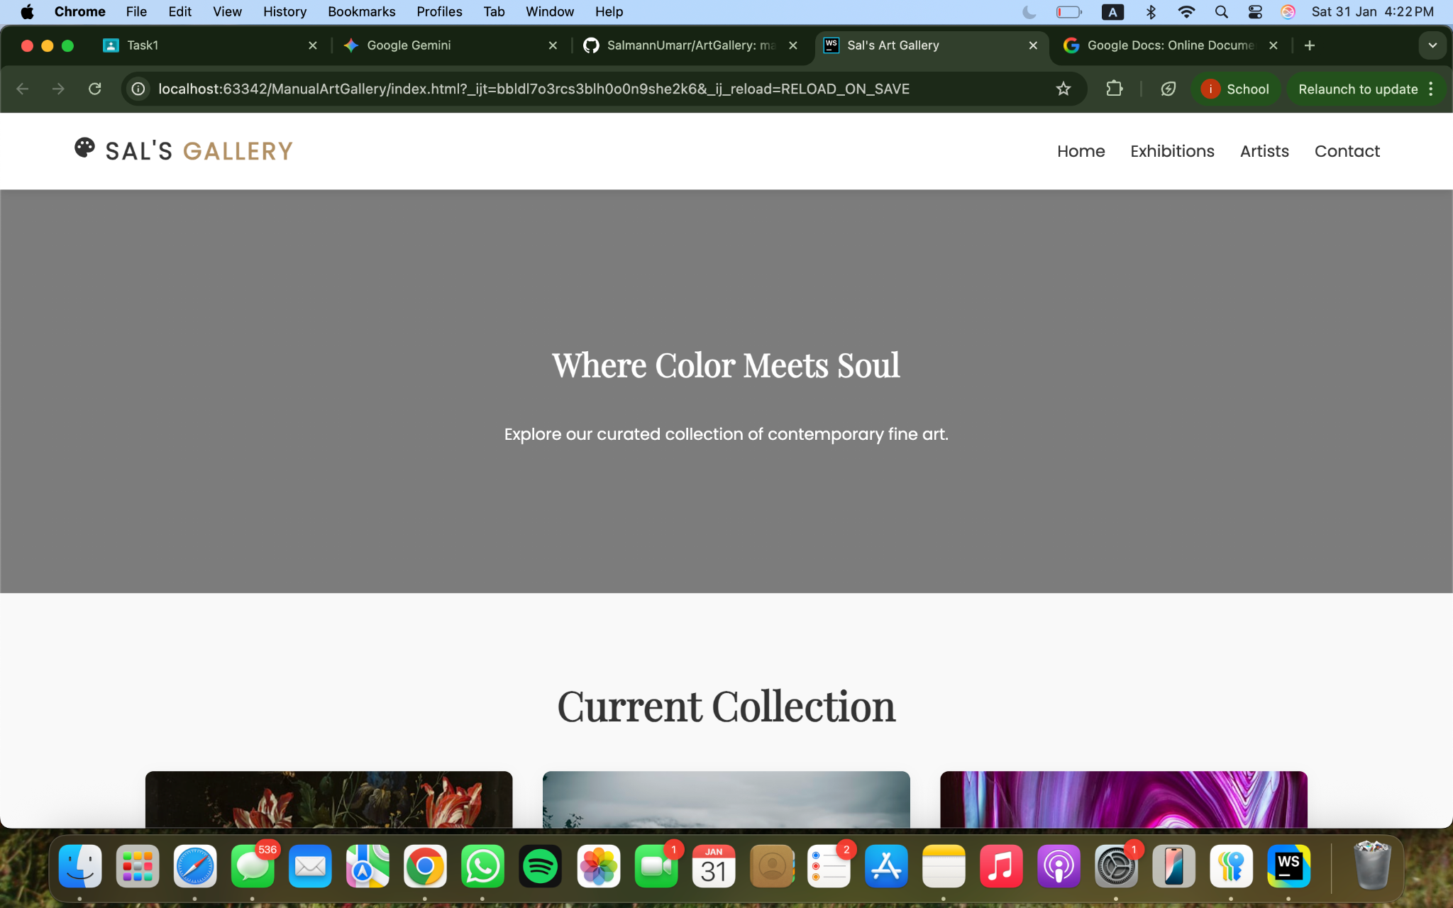  
  
  
**Gen AI Website**

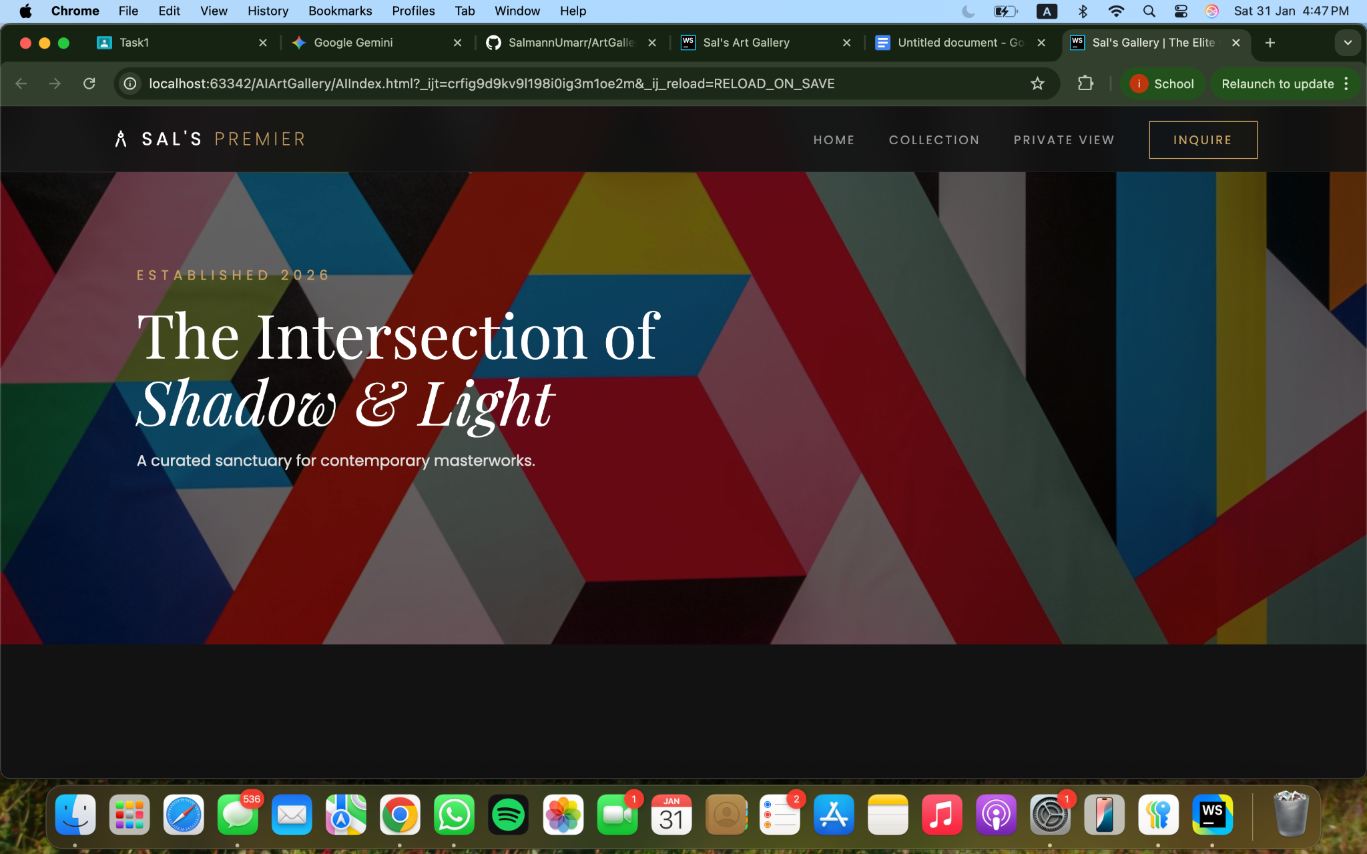

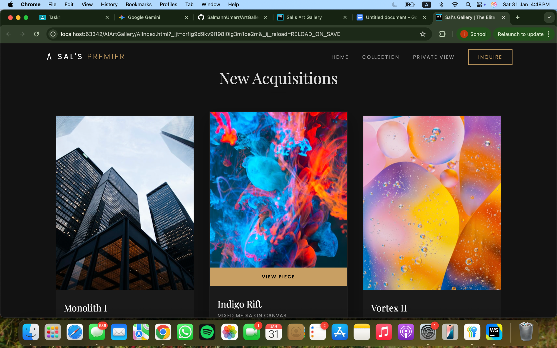

**Prompts Used:**

* this is a website i created manually - it includes HTML5 and CSS, I want you to refine the website without changing any of the core functionality - you can add new features and build upon the base provided
* can you make some improvements? i dont want it to look exactly like the website i provided - change the photos, background colors and make it look like a better, upgraded version of the website i provided
* would you like to analyse the website i provided vs the website you made and write down what you observed, the differences and what there is for me to learn?

**Analysis and Comparison:**

## **1. Visual Hierarchy & Mood**

* Original: Used a high-contrast white background with standard padding. It felt like a clean, functional e-commerce catalog.
* Refined: Switched to a "Dark Gallery" theme. In the art world, dark backgrounds are often used to reduce visual noise, making the colors in the artwork appear more vibrant and "expensive."
* Learning Point: Color Psychology. A white background feels "open and accessible" (like IKEA), while a dark/charcoal background feels "exclusive and premium" (like a high-end gallery).

## **2. Layout & Spacing**

* Original: Used a classic 3-column grid. It was perfectly functional but felt a bit "static."
* Refined: Introduced CSS Variables (:root) and Editorial Alignment. By shifting the text to the left and adding a thin border around the cards, the layout feels more like a modern art magazine than a standard website.
* Learning Point: Whitespace (Negative Space). Giving elements more room to breathe (like the increased padding in the figcaption) prevents the user from feeling overwhelmed and guides their eye to the most important element: the art.

## **3. Micro-Interactions (The "Feel")**

* Original: Had a basic hover scale effect.
* Refined: Added a Layered Hover State. When you hover over the new cards, the image zooms slightly (transform: scale(1.08)), the brightness increases, and a "View Piece" bar slides up from the bottom.
* Learning Point: Visual Feedback. Good UI tells the user what is "clickable" without using words. These smooth transitions create a sense of polish and high-end engineering.

| Feature | Your Original | My Refined Version | Why it Matters |
| --- | --- | --- | --- |
| Header | Standard White | Glassmorphism (Blur) | Stays readable over any scroll content. |
| Grid | Fixed 3-column | auto-fit Responsive | Works better on different screen sizes. |
| Images | Direct Links | Frame-contained | Prevents layout "jumping" if an image fails. |
| Variables | Hardcoded Colors | CSS :root Variables | Makes it 10x faster to change themes later. |

## What there is for you to learn:

1. CSS Variables: Notice how I used --primary throughout the CSS. If you decide you want the gold color to be blue tomorrow, you only have to change it in *one* place (the :root) instead of searching through the whole file.
2. Glassmorphism: The use of backdrop-filter: blur() in the header is a very modern technique used by Apple and Microsoft to create depth.
3. Containment: By wrapping your <img> in a div (like .img-frame), you can perform animations on the image (like zooming) without it overlapping other parts of the website. It keeps your design "contained" and neat.